IPV – Module Description

**Table of contents**

Image Processing & Vision (IPV) 1

Prerequisites 1

Learning objectives 2

Activity 2

Assessment 2

# Image Processing & Vision (IPV)

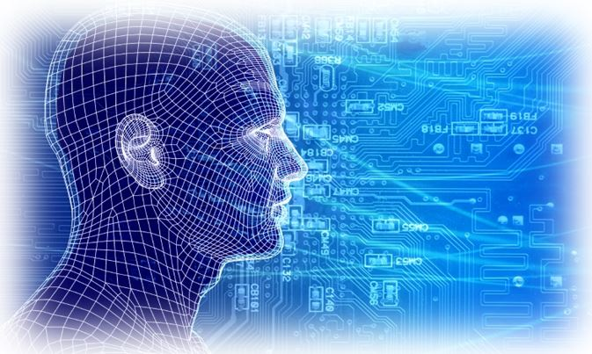

This course is an introduction of the basics/advanced techniques of **image processing** and **computer vision**

# Prerequisites

Students need to pass all the following courses:

* Programming courses from the first and second year
* Math2 course

# Learning objectives

* knows the basics of image processing (pixels, color representation, color depth).
* knows what a convolution filter is, and can implement such a filter on the pixel level.
* knows when to use some basic filters: mean, median, Gaussian, Sobel.
* knows how to apply Hough line detection.
* knows the k-nearest technique and can apply it to recognize digits.
* knows the Haar cascade technique and can apply it to recognize certain objects, like face, mouth, eye.

# Activity

* weekly assignments(check the share point IPV assignment part), to be delivered in Canvas

# Assessment

**Week 1 is the registration for this course. You must be present and register yourself if you would like to select this course.**

The final grade of IPV course is based on **three assignments (week 2, 3 and 4)**, which students have to submit their corresponding assignment on canvas before the deadline, that is :

* These three assignments (week 2, 3 and 4) must be submitted on CANVAS on week3, 4 and 6 respectively.(**deadlines are strict! If you miss the deadline, you get 0 for that week**).
* For each of these three assignments (week 2, 3 and 4) students will get a grade:
* **The practical session of week3, 4 and 6 are mandatory.**
* Three assignments (week 2, 3 and 4) will be checked selectively during **the practical session** of week3, 4 and 6 respectively. Students should be able to demo the assignment that they submitted to the teacher and explain clearly what they have done. If not, your grade for that assignment will be 2.
* If **your .mlx file** in the assignment does not compile or cannot run on the computer of the teacher (e.g., due to missing images, syntax errors, etc.) , then your assignment will not be checked, and your grade for that assignment will be 2.
* It is allowed to have **at most one grade 5** for assignments in week 2, 3 and 4.
* The final IPV grade is the average grade for assignments in week 2, 3 and 4.

Assignments in weeks 1 and 5 are for students to practice.

|  |  |  |  |  |
| --- | --- | --- | --- | --- |
| Week | Topic | Assignment | Canvas deadline  ( for IPV final grade) | Practical session: check/demo |
| **1** | **Matlab, DIPimage, loading and display image** | **Individual task** |  |  |
| **2** | **Image filtering: Blurring; derivative filters; sharpening; local maximum &minimum filters** | **Team task** | **assignment 2** |  |
| **3** | **Point operations (histogram-based operation, thresholding )** | **Team task** | **assignment 3** | **Check assignment 2** |
| **4** | **Binary morphology** | **Team task** | **assignment 4** | **Check assignment 3** |
| **5** | **Machine learning (recognize digits)** |  |  |  |
| **6** | **Computer Vision(Object Detection and Recognition, Hand gesture detection)** | **Team task** |  | **Check assignment 4** |
| 7 |  |  |  |  |